**Wireless Neural Recorder:**

**Energy-Efficient High-Throughput Wireless Transmission of Multi-Channel Neural Signals**

**Submitted to:**

**Dr. Nitin Tandon, UTHealth**

**&**

**Dr. Aydin Babakhani, Rice University**

**by**

**Xin Huang**

**on behalf of**

**WNR Senior Design Team**

**[Yuan Gao, Xin Huang, Tingkai Liu, Stephen Xia]**

**Department of Electrical & Computer Engineering**

[**RiceWNR@gmail.com**](mailto:RiceWNR@gmail.com)

**Submitted on: 4/20/2016**



**Table of Contents**

|  |  |
| --- | --- |
| **Executive Summary** | **3** |
| **Introduction** | **5** |
| **Design Strategy** | **7** |
| **Problem Description** | **7** |
| **Problem Decomposition** | **7** |
| **Design Requirements** | **8** |
| **Concept Generation** | **9** |
| **Concept Screening** | **27** |
| **Design Decisions Summary** | **30** |
| **Final Design** | **32** |
| **Introduction** | **32** |
| **System Breakdown** | **33** |
| **Analog Front End** | **33** |
| **Compression** | **35** |
| **Bluetooth Low Energy(BLE) Wireless Transmission** | **36** |
| **Power Systems** | **39** |
| **WNR System Housing** | **40** |
| **LBM Cost Analysis** | **40** |
| **Standards and Regulations** | **41** |
| **Conclusion** | **45** |
| **Testing and Results** | **46** |
| **Summary and Recommendations** | **55** |
| **Appendix A. Power Estimation for Intan RHD2000** | **57** |
| **Appendix B. Power Estimation for TI CC2650 and TI CC110L** | **57** |
| **Appendix C. Power Estimation for TI CC2564 + TI MSP430F5438 System** | **58** |
| **Appendix D. Power Estimation for Nordic nRF52 Chip** | **59** |

# 

# 

# **Executive Summary**

This document seeks to provide a comprehensive review of Team Wireless Neural Recorder(henceforth referred to as Team WNR)’s project background, goal, status as well as plans for future. Team WNR seeks to create a high-throughput, low-power wireless alternative to current Electrocochleography(ECoG) technologies which still largely employ a wired solution. By creating a small wireless module that can be screwed onto the existing depth electrodes used in ECoG operations, our product drastically improve the standard of living of ECoG patients’ as it will allow almost complete mobility of the patients during the monitoring process. Currently, we have developed our prototype and are pushing for animal testing during the coming summer.

*Background & context:*

About 10% of the world’s population suffers from epilepsy, and some of these patients require invasive ECoG operation for diagnosis. The current method of collecting ECoG data from a patient’s brain is through a tethered cord to a monitoring and recording device on premise at a clinic or hospital. This tethered procedure is high invasive and disruptive to patients’ lives as they are confined to a hospital bed for several days to a week while doctors wait for very small windows of epileptic episodes to occur to gather a limited amount of useful information.

*Design criteria and strategy:*

Wireless Neural Recorder’s (WNR) mission is to create a wireless monitoring solution to the problem of neural recording, allowing users the freedom and mobility to return to their normal lives at the hospital or at home while also enabling doctors to obtain sufficient neural data required to treat their patients’ conditions effectively. WNR seeks to create a secure, low-energy, and highly efficient embedded system that transmits at least the same amount of data as a traditional intracranial EEG at the same or higher resolution.

*Project status:*

The development process is planned in the following phases:

1. Market research for chips need for the purpose
2. Initial prototyping using development kits of chips found in phase 1
3. Design and Fabricate custom PCBs which meets design requirements
4. Assemble chips with custom PCBs and perform various testings
5. Second Round of PCB design and testing
6. Securing approval for animal testing and begin animal testing
7. Secure FDA approval for clinical trials

Currently, we have completed the first 4 phases and are in the process of phase 5. We plan to complete phase 5 by the end of the semester year so that future work can proceed with the sponsors to start securing approval for animal testing.

# **Introduction**

1 week of almost complete immobility while undergoing numerous seizures with depth electrode implanted into the brain is what severe epilepsy patients have to endure during ECoG operations. For the hundreds of thousands of severe epilepsy patients, Team WNR hope to provide an alternative to currently existing ECoG operation that will allow almost complete mobility by removing the wires that tether patient’s brain to a bedside monitor.

About 10% of the world’s population suffers from epilepsy, a brain function disorder that causes neurons in patients’ brain to fire at an abnormal rate with unregulated patterns. Diagnosis of this condition often involves a medical procedure called electroencephalogram (EEG), which detects the electric pulses created by the neurons.

Scalp EEG does not provide the resolution of brain activity data required for neurosurgeons to operate on as the cerebrospinal fluid, skull and scalp smear the electrical potentials from the scalp electrodes. To perform the epilepsy surgery, an ECoG operation is required to acquire higher resolution data to pinpoint which part of the brain is responsible for epileptic episodes and need to be removed.

The current method of collecting intracranial ECoG data from a patient’s brain is through a tethered cord to a monitoring and recording device on premise at a clinic or hospital. This tethered EEG procedure is high invasive and disruptive to patients’ lives as they are confined to a hospital bed for several days to a week while doctors wait for very small windows of epileptic episodes to occur to gather a limited amount of useful information.

Team WNR is producing a new ECoG (a.k.a. Intracranial EEG) electrode that incorporates wireless connectivity via Bluetooth Low Energy between each individual intracranial electrode probe and a central recording terminal. Each electrode will be attached to a low-power analog to digital unit that will read and transmit neural data to a bluetooth microprocessor to transmit wirelessly in real-time to a receiver. An array of up to 16 wireless electrodes should be able to transmit simultaneously to a single recording receiver. From the receiver, medical professionals can access the data in real-time and analyze the captured data to best treat the patient. Our embedded system seeks to untether the patients and give them their mobility and their life back.

The target market that our project focuses on is the 10000 health care providers and the 150 research institutions that utilizes ECoG machines for research purposes. The market value with wireless ECoG machine will be approximately $90 Million dollars with an annual projected revenue of $9 Million dollars.

We look at our competitors against whom our product will compete for the final contract. For our wireless neural recorder, we found that are very few existing commercial ECoGs rated for wireless human brain wave test data recording and monitoring. This is because prevalent ECoG technology is generally wired and limiting in terms of the freedom and dignity of epilepsy patients, and wireless ECoG recording is a very new field with very few competitors. We identified our two main competitors to be BLACKROCK MICROSYSTEMS, DEUTRON and NEUROPACE, but their technologies have limitations that make their options less than ideal.

For the remainder of this document, details of the design strategy, our current progress status and relevant testing and results will be discuss to provide a more holistic view of the project’s prospect. It will serve to illustrate the uniqueness of WNR’s wireless solution being high-throughput, low-power, secure and its potential of freeing countless epilepsy patients from the immobility of ECoG operations.

# **Design Strategy**

## **Problem Description**

WNR seeks to produce a new ECoG (a.k.a. Intracranial EEG) electrode that incorporates wireless connectivity between each individual intracranial electrode probe Each electrode will be attached to a low-power wireless control unit that will read and transmit neural data in real-time to a receiver. An array of up to 16 wireless electrodes should be able to transmit simultaneously to a single receiver. From the receiver, medical professionals can access and analyze the captured data to treat the patient.

## **Problem Decomposition**

The overall system takes the following inputs and generates the following outputs:

1. Inputs: analog electrical pulses generated by the brain
2. Outputs: wirelessly received lossless converted digital electrical signals generated by the brain

The main difference between our product and existing designs is that we will transmit the data to the receiver wirelessly from each individual electrode probe, while most products on the market either directly connect their recording instruments to the receiver using wires or have a wireless module that is connected to a group of probes. Our design is probe independent and can be configured to work with either 1 probe up to 32 probes.

In order to achieve our final product, we have decomposed our design to the 4 parts, as illustrated in the diagram below.

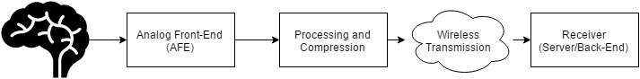

**Figure 1.** System block diagram of the wireless neural recorder.

The electrical signals from the brain will be sampled and digitized by the analog front-end. The analog front-end must ensure that the signal is recorded and digitized with a high signal-to-noise (SNR) and that the signal is amplified so that the signal amplitude is within the range of acceptable values of current analog-to-digital converter (ADC) technology. The output of the analog front-end is the digitized signal of the electric activity occurring at the site of contact between the electrode and the brain.

Once the signal is digitized, a microcontroller will process the digital signal for wireless transmission. Our embedded system aims to be a low-power wireless solution. We have read the spec sheets and done basic theoretical calculations for both A2D and wireless in Appendix A & B. Wireless transmission will consume the most power out of all the components of our system, so we will have to reduce the amount of power consumed by wireless transmission. If we transmit raw data from all electrodes in the system simultaneously to the receiver, we may not have enough bandwidth using a low-power scheme to transmit the data in real-time from all electrodes. As such, we may want to apply compression or data decimation methods to reduce the amount of data we need to transmit to avoid overflowing the wireless transmission channel. This portion is addressed in the preprocessing and compression portion of the system.

After preprocessing, the data will be wirelessly transmitted to the receiver. Since wireless communication are more prone to noise than wired connections, rather complicated protocols are required to modify the packages to be sent. Fortunately, robust protocols like TCP already exist and can potentially be incorporated into our product.

Finally, the signals transmitted wirelessly will reach a receiver which could be a phone application that stores the data for users to view and analyze. Data could potentially be recorded and transmitted in real-time in order for our neural recorder to function as an effective real-time brain activity monitoring system. The back-end component of the system is extremely flexible. It can be a phone application, a personal computer, a server, etc. Since any of these options would satisfy the requirements of the system, the following sections do not detail the platform that will be used in the back-end system design. Instead since the front-end portion of the system have much more stringent requirements, the following sections will describe the decisions made about these subsystems in detail.

## **Design Requirements**

The following design specifications were given to us by Dr. Nitin Tandon from UTHealth.

1. Dimensions:
   1. The entire device should fit in a cap of size 15 x 15 x 15 mm (ideally 5 x 5 x 10 mm).
2. Power:
   1. The device should operate continuously for at least 12 to 24 hours without changing the battery.
3. Electrode Specifications:
   1. An array of 16 electrodes
   2. Each electrode has 16 channels
4. Data Requirements:
   1. 0.5 to 1 kHz sampling rate for each channel on each electrode
   2. At least 8-bit ADC precision
   3. 1000 x 16 x 16 x 8 = 2 Mb/s raw data
5. Safety:
   1. Local temperature change around electrode should not exceed 2oC / 3.6oF
   2. No backward current flow into patient’s brain

## **Concept Generation**

1. Analog Front-End:

Given the low amplitudes of input signals, low-noise become a very important design requirement. At the same time, power consumption also needs to be considered as the system would need to fit in a very small form factor, hence limiting the size of the battery and the total power supply.

With these two design requirements in mind, we engaged in market research for commercially available AFE chips and found several options:

1. Intan Technologies – RHD2000 series

|  |  |
| --- | --- |
| **Component** | **Features** |
| ADC | * 16-bit * 32 channels * Max 30,000 Samples/Second |
| Amplifier | * Cutoff frequency adjustable:   + Upper: 100 Hz – 20 kHz   + Lower: 0.1Hz – 500 Hz * Input Referred Noise:   + 2.4 uVrms |
| Connection | * 16-bit SPI with either of the two signaling methods   + Standard – referenced to GND, more prone to noise   + LVDS – referenced to a negative pin, more resistant to noise |
| Additional Capabilities | * *In situ* electrode impedance measurement * Temperature sensor |
| Power Consumption | * Estimated (in **Appendix A**) to be 2.99 mW and 21.74 mAh for 24 hour continuous operation |
| Safety | * Built-in protective circuitry that prevents backward current flow into electrode * Built-in temperature sensor to monitor local temperature to avoid overheating |

**Table 1.** Features of Intan Technologies RHD2000 series

The Intan RHD2000 series, at a first glance, seems to provide everything that the project requires for the analog front-end. There are more than enough channels on the chip to read in 16 channels from the electrode, with very low lower cut off frequencies (as low as 0.1 Hz). Additionally, the amplifier has a very low input referred noise, which provides high signal-to-noise ratio amplification. The following table lists out the cost of the various products that is associated with the Intan RHD2000 series.

|  |  |  |
| --- | --- | --- |
| **Product** | **Specifications** | **Price (in $/unit)** |
| Amplifier Boards | RHD 2216 with 16 Bipolar inputs **++** | 725 |
| RHD 2132 with 32 Unipolar inputs | 895 |
| RHD 2164 with 64 Unipolar inputs | 1785 |
| Electrode Adaptor | Board | 255 |
| 36-Pin Wire | 190 |
| SPI Adaptor | Breakout for 12-pin SPI **++** | 98 |
| SPI cable | Standard 0.9m **++** | 215 |
| Ultra-Thin 0.9m | 415 |
| USB interface Board | Development Board for RHD2000 series | 2755 |

**Table 2.** Costs of Intan Technologies RHD2000 series and related Products.

( **++**: Minimum components required)

A complete evaluation system of Intan RHD2000 will cost from $3793 to $5488. With a minimum development cost of $1038 for only the amplifier board.

However, we can lower the cost by only purchasing the amplifier board with SPI cable and SPI adaptor board which will cost a total of $1038 - $2098 (depending on the choice of amplifier board).

1. Texas Instruments - ADS1299

|  |  |
| --- | --- |
| **Component** | **Features** |
| ADC | * 24-bit delta-sigma ADC * 8 channels * Max 16,000 Samples/Second |
| Amplifier | * Programmable Gain:   + 1,2,4,6,8,12,24 * Bandwidth scales with respect to gain:   + 622 kHz(1x gain) - 27 kHz (24x gain) * Input Referred Noise:   + 1.0 uVpp |
| Connection | * standard SPI |
| Additional Capabilities | * Temperature sensor |
| Power Consumption | * 5 mW/Channel |
| Safety | * Patient protection resistor |

**Table 3.** TI ADS1299 Features

|  |  |  |
| --- | --- | --- |
| **Product** | **Specifications** | **Price (in $/unit)** |
| ADS1299 | * Only come in TQFP packagings * Sell in quantities of thousands | 0.038 |
|
|

**Table 4.** TI ADS1299 Cost

The main point of comparison between the TI ADS1299 and the Intan Chip is the safety mechanism; every other specification, like input referred noise, is somewhat similar in terms of what the wireless neural recorder project requires. Additionally, safety is one of the top concerns in choosing the component for digitizing neural signals because this component will be directly interfacing with the human brain via an electrode. As such, creating a circuit that can read in data, while not affecting the natural chemical and electrical state of the brain is very crucial. The TI ADS1299 has only a single protection resistor within the chip’s circuitry. However, the Intan Chip has two entire components dedicated to ensuring that the ADC does not adversely affect the patient that the device will be implanted in. The Intan Chip not only limits the current flow back into the brain, but also regulates temperature change. This gives the Intan Chip an advantage over the TI ADS1299 for the wireless neural recorder application. The exact circuitry and concepts are detailed in a series of papers published by Intan’s founder, Reid Harrison. The process and final selection of either the Intan Chip or the TI ADS1299 is outlined in the concept screening section.

1. Preprocessing and Compression:

From the design requirements provided, a transmission rate of 2 Mb/s would only be satisfied if a higher power higher bandwidth wireless communication protocol, such as Wi-Fi, is used. The theoretical channel capacity of a lower power protocol, like Bluetooth Low Energy (BLE), is 1Mb/s, so the raw data should be compressed by at least a factor of two for reliable transmission.

The compression algorithm that was considered is called Adaptive Huffman Coding. This algorithm dynamically adjusts the Huffman tree data structure as data is being transmitted. An example of the Huffman tree data structure and the corresponding coding scheme is shown below.

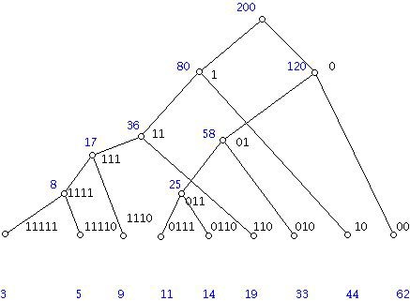

**Figure 2.** Example of Huffman tree with frequencies of codewords listed below[14]

The Huffman tree is a data structure that assigns long bit sequences with a short prefix representation, denoted by the path representing the bit sequence travelling down along the tree. Regular Huffman trees use fixed tree structures, where each long bit sequence is stored in a fixed location. Adaptive Huffman tree simply updates this tree structure by the frequency of occurrence of each bit sequence, by consecutively swapping nodes and leaves to achieve optimized performance. In figure 2, the frequency of each bit sequence is shown listed below the tree, and it follows that the most frequently occurring sequence is represented with the smallest number of bits. Huffman encoding is also a relatively common algorithm which makes implementation more convenient. The compression rate for Huffman encoding is at most 40%, which is slightly less than a reduction by a factor of two[14]. This method provides a starting point to begin wireless transmission testing once the prototype has been built. We will keep exploring other compression algorithms, especially if Huffman encoding turns out to be insufficient.

More on compression algorithms: below is a table of some typical ECG data compression schemes, together with their compression ratio[22].

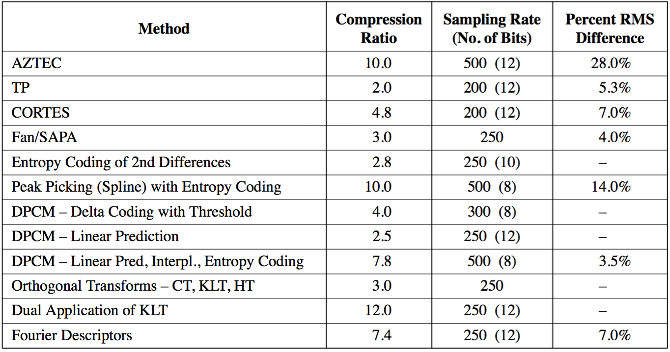

**Table 5.** Comparison of ECG Data Compression Algorithms

The LZ compression algorithm, which is widely applied in zipped files, has a relatively high compression ratio. An advanced LZ algorithm variant that is designed specifically for ECG data, called ALZ77[22], can achieve a compression ratio of 31.4 when a RMS difference of 1.6% is tolerated. The feasibility of implementing such an algorithm on a microprocessor is still under investigation, which may greatly impact the final choice of wireless protocol that supplies less bandwidth.

1. Power Source:

Our power needs is one of the biggest challenges as our design requirements are quite aggressive. The device must meet or exceed the following expectations:

1. Last 12-24 hours while collecting data
2. Only change or charge device at most once per waking day
3. We calculated the capacity of our system had to provide at minimum 240 mAh
4. Be medically safe
5. Do not return DC current into needle probe into brain
6. Do not heat up with a change above 2 degrees centigrade
7. Be within the total size constraints of maximum 8mm diameter by 10mm height

Powering such a device that is so small yet so power hungry proves to be a big challenge that required extensive energy research. The research ranged from unconventional medical device techniques such as wireless charging[5] to tried and true conventional methods such as batteries. Given that the brain is a very sensitive and important part of our lives and our device will be directly interfacing with it, we decided to go with the more conventional and safer option of powering the intracranial EEG data recorder with batteries. However, even using battery technology, there was still a large amount of work to be done in order to decide on a battery technology that could best fit our needs.

The first area of research would be the battery chemistry to use for our battery. Items that were under consideration were energy density, discharge rate, safety, weight and size, and lastly cost. There were dozens of battery chemistries, each with their pros and cons for specific applications in regards to performance and cost. In figure 3, the 6 most common battery make-ups are compared but only Lithium[7] based batteries could provide us the energy density for the size, weight, and capacity that we required. However even then, Lithium based batteries, while popular, could not be the only technology we look into as it still had several cons despite class leading energy density and low discharge rate. A flaw in Lithium based technologies is that it requires protection circuits to limits voltage and current and the lithium battery is safe if not provoked by extreme temperatures or physical damage. While these were somewhat minor cons that could be designed against to meet our second requirement of being safe, we researched into less conventional batteries such as silver-zinc and zinc-air[8].

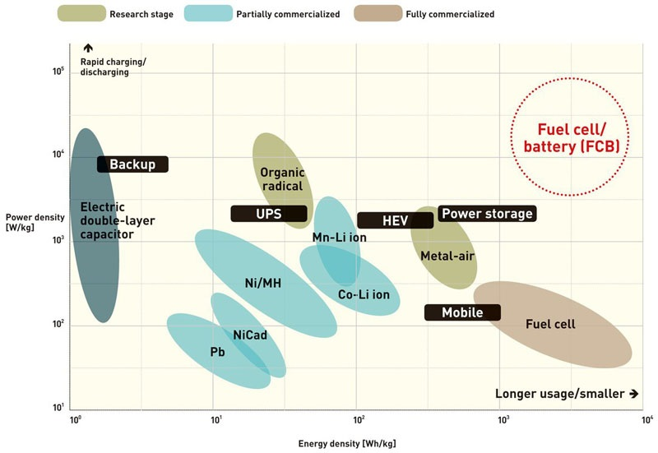

**Figure 3.** Power density and sustainability of current battery technologies[18]

Zinc-air, a less conventional battery chemistry but now highly common in hearing-aid devices, caught our attention and seemed to be a viable competitor to Lithium based batteries. Zinc-air batteries generate electrical power by an oxidation process of zinc and oxygen from the air and as such it has high specific energy, low discharge, and comes in a variety of sizes while also staying low-cost[9] and low weight due to the lack of need to package atmospheric air for its operation.

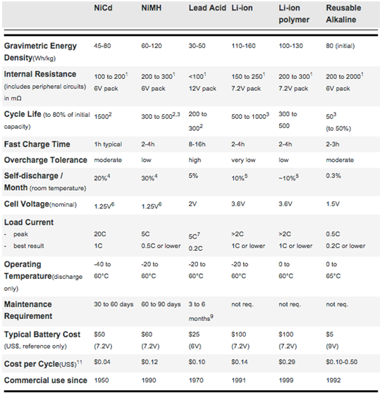

**Figure 4.** Comparison of 6 Common Battery Types[6]

1. Wireless Transmission:

Our data transmission needs continues to prove itself as our biggest challenge as we are sending large amounts of data continuously. Our device was given the following requirements as an optimal operating mode:

1. Support up to 16 intracranial probes
2. Each intracranial probe has 16 electrodes
3. Each electrode outputs 8 bits, sampled at 16 bits due to Nyquist Frequency
4. Data sampled at 0.5 to 1 ks/s
5. Send data over a range of at least 3 m

Given the worse case scenario, our device will use 16 x 16 x 16 x 1 bits = 4 Mb/s. This is a lot of data to be transmitted in parallel, continuously every second. However after consulting with our PhD mentors, professors, and TI engineers, we concluded that our device could possibly work well with sending less data with a few techniques such as decimation, compression, and buffering. Instead of sending the full 4 Mb, it would instead:

1. Each electrode outputs 8 bits, sampled at 16 bits but decimated back to 8 bits during transmission
2. Data sampled at 0.5 ks/s instead of 1 ks/s because most of the data is low frequency

This makes our worse case scenario a little bit better, as our device will use 16 x 16 x 8 x 0.5 = 1 Mb/s. This is a 4x reduction in necessary bandwidth, which is much more reasonable and achievable. This reduction in bandwidth requirements before compression allows us to consider multiple wireless technology options and different network topologies[15]. A table of a few notable comparisons between technologies is listed on the following page:

|  |  |  |  |  |  |  |  |  |  |
| --- | --- | --- | --- | --- | --- | --- | --- | --- | --- |
|  | Bluetooth  EDR | Bluetooth Low Energy  (LE) | Wi-Fi | Radio Frequency for Consumer Electronics  (RF4CE) | ANT+ | Nike+ | Infrared  Data Association  (IrDa) | ZigBee | Near Field  Commu-nication  (NFC) |
| Cost | Low | Low | High | Medium | Medium | Medium | Low | Low | Medium |
| Power  Efficiency | <165.9 μW/bit | 0.153 μW/bit | 0.00525 μW/bit | <185.9 μW/bit | 0.71 μW/bit | 2.48 μW/bit | 11.7 μW/bit | 185.9 μW/bit | >185.9 μW/bit |
| Operating  Range | 100m | 100m | 150m | 100m | 30 m | 10 m | 10 cm | 100m | 5 cm |
| Throughput | 2.1 Mbps | 1 Mbps | 54 Mbps | ~424 kbps | ~20 kbps | ~20 kbps | ~1 Gbps | ~100 kbps | ~424 kbps |
| Latency | 3ms | 2.5ms | 1.5ms | ~20ms | ~0 | ~1s | ~25ms | ~20ms | ~1s |
| Peak Current  Draw | ~30 mA | ~ 12.5 mA | ~ 116 mA | ~ 40 mA | ~ 17 mA | ~ 12.3 mA | ~ 10.2 mA | ~45 mA | ~ 50 mA |

**Table 6.** Comparison of low power wireless transmission protocols

We also looked into network topologies and our research included the 5 main network topologies exist when discussing personal low-power radio networks:

1. Broadcast: A message is sent from a device in the hope that a receiver within range receives it. The broadcaster doesn't receive signals.
2. Mesh: A message can be relayed from one point in a network to any other by hopping through multiple nodes.
3. Star: A central device can communicate with a number of connected devices — Bluetooth is a common example.
4. Scanning: A scanning device is constantly in receive mode, waiting to pick up a signal from anything transmitting within range.
5. Point-to-Point: In this mode, a one-to-one connection exists, where only two devices are connected, similar to a basic phone call.

The wireless technologies we looked at can support the following network topologies as seen in figure 5.

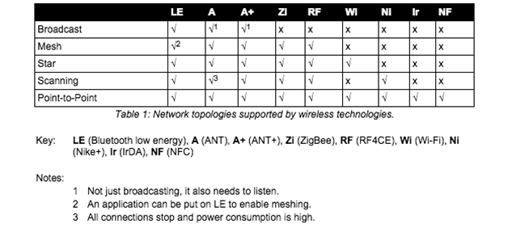

**Figure 5.** Wireless Technology Network Topology

There was another technology that we found called Ultra Wideband (UWB)[16], as seen in figure 6, that could have fulfilled all our needs and given us the 4 Mb/s bandwidth that would have given us the most optimal performance but unfortunately the standard was abandoned due to fighting between competing factions. Unfortunately that puts UWB out of the running even though it had to potential to be a great wireless technology for our needs. Amongst the existing technologies, given that only Bluetooth EDR, Bluetooth Low Energy and Wi-Fi meet our bandwidth and operating range needs, we narrowed it down to those two technologies to weigh the pros and cons of the two. However, given that Wi-Fi has a high power draw, compute resources, and slightly higher cost, we decided to choose Bluetooth Low Energy as the wireless technology that we will focus on in creating our prototype due to the fact that is has great range, low power draw, and decent bandwidth at 1 Mb/s. However we soon figured out that Bluetooth Low energy, while it has sufficient bandwidth does not have enough throughput to support our needs as it’s max throughput is only 0.3 Mb/s[19], much lower than what we need at the absolute minimum of 1 Mb/s. We have decided to focus on Bluetooth v2.1 EDR as the main transmission protocol as we should be able to send our ideal 2 Mb/s through it without the need for compression.

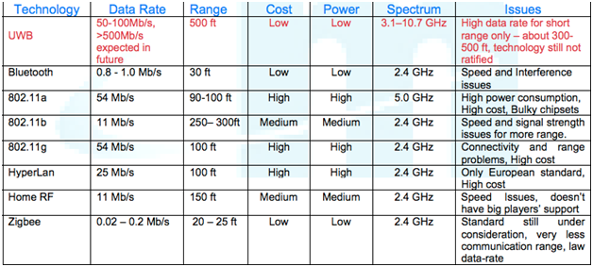

**Figure 6.** UWB vs. BLE vs. Wi-Fi

The Bluetooth radio interface has been designed to enable communications to be made reliably over short distances. The radio interface is relatively straightforward, although it has many attractive features. The Bluetooth radio interface supports a large number of channels and different power levels, as well as using reliable forms of modulation. Running in the 2.4 GHz ISM band, Bluetooth employs frequency hopping techniques with the carrier modulated using Gaussian Frequency Shift Keying (GFSK). With many other users on the ISM band from microwave ovens to Wi-Fi, the hopping carrier enables interference to be avoided by Bluetooth devices. A Bluetooth transmission only remains on a given frequency for a short time, and if any interference is present the data will be re-sent later when the signal has changed to a different channel, which is likely to be clear of other interfering signals. The standard uses a hopping rate of 1600 hops per second, and the system hops over all the available frequencies using a predetermined pseudo-random hop sequence based upon the Bluetooth address of the master node in the network.

Bluetooth Low Energy shares some similarities with Classic Bluetooth. Both use the 2.4 GHz spectrum. Basic Rate (BR) and BLE both use GFSK modulation at 1Mb/s, but their modulation index is different. Enhanced Data Rate (EDR) uses a completely different modulation than GFSK. Classic Bluetooth has 79 channels compared to LE’s 40 channels. The channels are also spaced differently. Both of these differences make LE and Classic different and incompatible, so they cannot communicate to each other[17]. We can see the difference between Bluetooth Low Energy and Classic in figure 6, with Bluetooth Low Energy being able to theoretically support our 1 Mb/s bandwidth requirements but unable to support our throughput requirements. Bluetooth BR has almost the same power requirements as EDR but half the bandwidth, so it is more cost effective for us to use Bluetooth EDR and take advantage of the increased throughput and bandwidth.

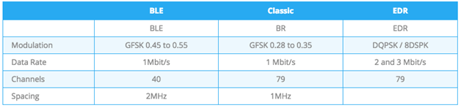

**Figure 7.** Comparison Between BLE and Classic

Bluetooth has two ways of communicating. The first one is using advertisements, where a Bluetooth peripheral device broadcasts packets to every device around it. The receiving device can then act on this information or connect to receive more information. The second way to communicate is to receive packets using a connection, where both the peripheral and central send packets. Bluetooth Advertising is one of the most important aspects of the Bluetooth protocol. This is seen, as a connection between two devices without using advertisements is impossible. Defining the data and format of advertisement packets is usually the first thing you work on when developing a Bluetooth device. Also, a large number of Bluetooth products sleep most of the time, waking up only to advertise and connect when needed. This means advertisements have a big impact on power consumption.

The 2.4GHz spectrum for Bluetooth extends from 2402 MHz to 2480 MHz, as seen in figure 8. BLE uses 40 1 MHz wide channels, numbered 0 to 39. Each is separated by 2MHz. Bluetooth Classic uses 79 channels, each with a bandwidth of 1 MHz. During Bluetooth advertisement, a Bluetooth Peripheral device transmits packets on the 3 advertising channels one after the other. A Central device scanning for devices or beacons will listen to those channels for the advertising packets, which helps it discover devices nearby.

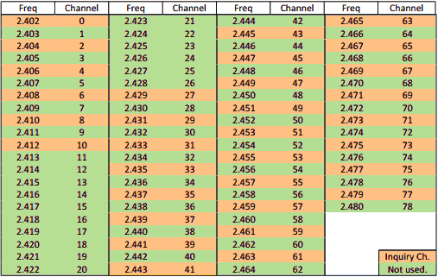

**Figure 8.** Bluetooth Channels

We researched and found that for Bluetooth Low Energy, the current standard is BLE 4.2, which is more power efficient and secure but Bluetooth v4.2 hasn’t made it yet to the market completely because it requires updated hardware and because it requires support on both sides of the link for transmitting and receiving. Even then, the new 4.2 revision would not have the throughput we need for our project. We also notice that most of the devices available are Single Mode only, and that most of those run v4.1 of the Bluetooth Specification, which is still new but well documented and still decently low power. Meanwhile, Bluetooth EDR is on Bluetooth Classic version 2.1 and that is the latest standard we are using and was last introduced and updated in 2007. We also noticed that dual mode bluetooth devices are not as popular because of cost and the complexity of supporting Bluetooth Classic and BLE on the same chip. However, we did find and are using a dual mode, Bluetooth classic and low energy chip.

Looking into the current vendors and existing chipsets, there are a variety of options. However given that the ideal size constraint of the system (5 x 5 x 10 mm) is very small, our options for components are limited. The first option is the TI CC2650 chip. Its features and specifications are given below.

1. Texas Instruments - CC2650

|  |  |
| --- | --- |
| **Component** | **Features** |
| ADC | * 12-bit ADC * 8 channels * Max 200,000 Samples/Second |
| Transceiver | * 2.4 GHz RF Transceiver * Bluetooth Low Energy (BLE) 4.1 * Programmable output power up to +5 dBm |
| Microcontroller | * ARM Cortex M3 * Up to 48 MHz clock speed * 128 KB of In-System Programmable Flash * 8 KB SRAM for cache |
| Peripherals | * I2C * SPI * UART |
| Size | * 4 x 4 mm |
| Cost | * $5.95/unit |

**Table 7.** TI CC2650 features

Of the features listed in the table, the main components of interest are the transceiver, for transmitting data, and the microcontroller. The transceiver is directly used for data transmission. The microcontroller is useful for several applications other than wireless transmission and reading data from the analog front-end. It can also be used for processing and compressing data read from the analog front-end. Since the analog front-end will be a separate part of the system, the ADC component of the CC2650 does not need to be utilized. The following table lists out some of the specifications of the CC2650.

|  |  |
| --- | --- |
| **Specification** | **Value** |
| Wide Supply Voltage Range | * Normal Operation: 1.8 to 3.8 V * External Regulator Mode: 1.7 to 1.95 V |
|
|
| Active-Mode Transmission | * 0 dBm: 6.1 mA * +5 dBm: 9.1 mA |
| Active-Mode Receiver | * 5.9 mA |

**Table 8.** TI CC2650 specifications

The table shows that the same power supply of 3.3V used for the Intan RHD2000 series, described in the previous section, can also be used for the CC2650 chip. The main specification of interest is the Active-Mode transmission, since this specifies the amount of current the device draws as it undergoes wireless transmission. Calculations for the current draw and power consumption of the TI CC2650 chip is found in **Appendix B**.

Another option, suggested by Texas Instruments engineers, is to use the TI CC110L Value Line Transceiver to create a star topology of point-to-point connections from the receiver to all of the electrodes. Some of its features are enumerated on the following page.

|  |  |
| --- | --- |
| **Component** | **Features** |
| RF | * Output power up to 12 dBm * Up to 600 kb/s data rate * Three sub GHz frequency bands supported * Signal modulation supported |
| Low-Power | * 200 nA sleep mode current consumption * 240 micro-second wakeup time * 64-byte RX and TX FIFO |
| Size | * 4 x 4 mm |

**Table 9.** TI C110L features

The feature listed above that is most important to the project is the 600 kb/s data rate. This data rate is lower than the effective BLE data rate, which is around 750 kb/s. This means that using the C110L would decrease the system’s channel capacity. Of course, the most important specification that our system depends upon is the transmission power consumption. The following table provides the current consumption required for transmission at specific frequencies.

|  |  |
| --- | --- |
| **Transmission Frequency** | **Minimum Current Draw** |
| 315 MHz | * 12.3 mA |
| 433 MHz | * 13.1 mA |
| 868/915 MHz | * 14.7 mA |

**Table 10.** TI C110L transmission current draw

The current draw for transmission with the TI C110L is at least twice as much as transmission with the TI CC2650, making the TI C110L a less power efficient product in our project than the TI CC2650. Power consumption is calculated and analyzed in **Appendix B**.

As mentioned previously, the issue with using BLE is the limited application throughput. As such, the possibility of having to use a higher throughput, but greater energy consumption, protocol may be necessary, so the rest of the section will detail features and characteristics of the Bluetooth Classic components found.

Just as in the case of BLE, the chips we choose to use for Bluetooth Classic will have to be close to the size constraint given. Additionally, there were not very many Bluetooth Classic options available on the market because currently most applications are demanding BLE for their applications and the protocol is relatively old compared to BLE. In the end, the Bluetooth system that was decided upon to best fit our needs includes operating a TI CC2564MODN Bluetooth module through the MSP430F5438 MCU.

The features of the TI CC2564MODN are listed in the table below.

|  |  |
| --- | --- |
| **Component** | **Features** |
| RF | * Maximum Output Power: +12 dB |
| Protocols Supported | * Bluetooth Low Energy (BLE) * Bluetooth Basic Rate (EBR) * Bluetooth Enhanced Data Rate (EDR) |
| Clock | * Slow Clock: 32,768 kHz * Fast Clock: 26 MHz |
| Peripherals | * H4 Protocol - 4 Wire UART Interface * H5 Protocol - 3 Wire UART Interface |
| Size | * 8.10 x 8.10 mm |
| Cost | * $5.54/unit |
| Current Draw | * EDR at full data rate at +4 dBm: 39.2 mA |
| Power Supply | * Supports from 2.2 to 4.8 V input voltage |

**Table 11.** TI CC2564MODN features[20]

The main attraction of this chip is the fact that it can transmit using Bluetooth Classic (BR and/or EDR), meaning it can achieve a data rate of around 2 Mb/s. This would eliminate the need for an aggressive compression algorithm that would have to be implemented onto a microcontroller if BLE is chosen as the transmission protocol. However, unlike the TI CC2650, the CC2564 is not by itself a microcontroller. As such, an additional microcontroller must be used in conjunction with the CC2564 to operate it. The MSP430 is a classic option for viable low power microcontroller solutions. The MSP430F5438 is one of the few TI microcontrollers that comes with an experimenter board that directly interfaces with the CC2564. The MSP430F5438 MCU’s features are listed in the table on the following page.

|  |  |
| --- | --- |
| **Component** | **Features** |
| ADC | * 12-bit ADC * 14 external channels * 2 internal channels |
| Microcontroller | * 16-bit RISC architecture * Up to 25 MHz clock speed * 256 KB of In-System Programmable Flash * 16 KB SRAM for cache |
| Peripherals | * I2C * Synchronous SPI * UART |
| Size | * 7 x 7 mm |
| Cost | * $10.24/unit |
| Power Supply | * Supports Input voltage from 1.8 to 3.6 V |
| Current Draw | * 230 μA/MHz in active mode at 8MHz * 1.2 μA in low-power mode 4 (full RAM retention) |

**Table 12.** MSP430F5438 features[21]

The advantage of using a separate microcontroller with the Bluetooth module is that the microcontroller will have more memory for preprocessing and compression algorithms. The MSP430F5438 has twice as much Flash and twice as much cache memory as the CC2650. Additionally, clocking the microcontroller at 8MHz, only consumes around 2 mA. Compared with the current consumption of the CC2564, this is very little. The power consumption of the CC2564 is outlined in **Appendix C**. One thing to note is that the power consumption for the MSP430F5438 will most likely be lower than what is calculated because in the calculations, it is assumed that the MSP will be constantly in active mode. Additionally, the MSP will probably not have to be clocked at 8 MHz. Reducing the clock rate of the MSP will most likely reduce the amount of current draw per MHz. The following table lists our final consideration, the Nordic nRF52 chip.

|  |  |
| --- | --- |
| **Component** | **Features** |
| ADC | * 12-bit, 200 ks/s ADC |
| Microcontroller | * 128-bit AES ECB/CCM/AAR co-processor * 32 kHz crystal oscillator with option to go to 32 MHz low power crystal * 512 kB flash, 64 kB RAM |
| Transmission Protocol | * Bluetooth Low Energy (BLE) |
| Peripherals | * I2S * SPI * UART * PDM |
| Size | * 6 x 6 mm QFN |
| Cost | * $10.24/unit |
| Power Supply | * Supports Input voltage from 1.7 to 3.6 V |
| Current Draw | * 5.5 mA if Txing at +0dBm |

**Table 13.** Nordic nRF52 features[24]

The Nordic nRF52 has some very attractive features that many of the other options do not have. It has the most amount of processing memory we can use for transmission, sampling data, and compression. Additionally, it has the least amount of current draw out of the four options. There is more detail about the power consumption in **Appendix D**. The Nordic nRF52 uses BLE, so it has a data rate of 1 Mbit/s which is not the most ideal, but it could work depending on the type of compression we employ.

## **Concept Screening**

1. Analog Front-End (AFE):

After considering varying design criteria for AFE, Pugh Decision-Matrix was used to compare the Intan RHD2000 option and the TI ADS1299 option. The Pugh Decision-Matrix is shown below.

|  |  |  |  |  |
| --- | --- | --- | --- | --- |
| Criteria | Baseline | Weight | Intan RHD 2000 | TI ADS1299 |
| High precision ADC | 8-bits | 3 | + | + |
| Low Noise Amplifier | 3 uVrms | 4 | + | + |
| Safety | Protected circuitry and no backward current | 6 | + | - |
| Power Consumption* | << 300 mAh | 2 | S | S |
| Small Form Factor | < 8 x 8 mm | 5 | + | - |
| Cost | $1000 | 1 | S | + |
|  |  | Total | 18 | -3 |

* Baseline determined based on battery constraints

**Table 14.** Pugh Decision-Matrix for AFE

(**+** : beyond satisfactory, **-** : not satisfactory, **S**: Satisfactory)

The Pugh Decision-Matrix clearly shows, Intan RHD2000 is a better option than the TI ADS1299. Hence, going forward the Intan RHD2000 chip will be integrated into the system. The biggest factors contributing to which chip to use is the safety, size, and low noise amplification. Safety is most important, otherwise the product can not even be used in humans. The size must be small in order to place a few of them into one patient without causing physical and data interference among modules. Since signals from the brain are often times on the order of mA, an amplifier that does not amplify too much noise is crucial for obtaining accurate readings. In all three of these critical areas, the Intan Chip surpasses the TI ADS1299.

1. Preprocessing and Compression

As our design requirements requires us to transmit high amounts of data across through a small channel, the compression algorithm we choose must have a high compression ratio, but at the same time it needs to be able to fit on a microcontroller which has limited RAM. Given that the ALZ77 compression algorithm has a compression ratio that is almost three times greater than any other compression algorithm (31.4 compression rate), it would only be logical to look for an easy-weight implementation to use. It turns out, there is an implementation of a variation of ALZ77 called heatshrink, which takes only 50 bytes of RAM to run[23]. As such, this ALZ77 compression algorithm can be used on literally any microcontroller, making it the logical choice to use; This option offers the best compression rate at less than 1% of RAM usage of most microcontrollers in consideration.

1. Power Supply:

Given the choice between Zinc-Air and Lithium, we decided that while Lithium has a slightly higher energy density, its power stability cons and bigger standard size factors[10] were a limiting factor for us. We decided that Zinc-air’s small form factors would be our best viable option. The zinc-air batteries that we found for medical hearing aids came in 4 standard sizes, shown in figure 8, with varying diameter, height, and capacity. The only issue that we found was that the zinc-air batteries only provides 1.45V per cell but enough capacity at 300mAh at the p13 size. We believe that if we stack 2 p13 cells in series, we can get away with powering our devices at 2.9V, which is close enough to 3V, and that will continue to give us the 300mAh of the battery. This should be sufficient for our needs if our calculations are correct that our device should consume about 240mAh, which will give us 60mAh of buffer. This means that our capacity constraints are met but our size constraint would be slightly taller than what is optimal, as two batteries stacks would be 10.8mm, not including the rest of the components. However, we can ask for a height exception, as we would be creating prototypes and not creating custom batteries, which if we do for the production run, the battery size can fit within size constraints.

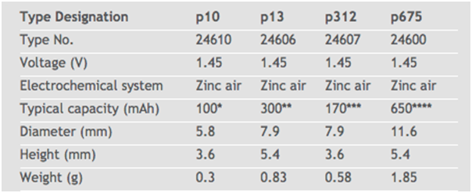

**Figure 9.** Zinc Air Battery Sizes

1. Wireless Communications:

The three systems considered for the microcontroller and wireless transmission are the TI CC2650, TI C110L Transceiver, and the TI MSP430F5438 + TI CC2564MODN Bluetooth module, which were outlined in the Concept Generation section. Again, a Pugh Decision-Matrix will be used to compare all three options against the specifications detailed in the Design Requirements Section.

|  |  |  |  |  |  |  |
| --- | --- | --- | --- | --- | --- | --- |
| Criteria | Baseline | Weight | TI CC2650 | TI C110L Transceiver | TI CC2564 + TI MSP430F5438 | Nordic NRF52 |
| Power Consumption* | < 300 mAh | 3 | + | - | - | + |
| Transmission Speed** | 1 Mb/s | 3 | S | - | + | S |
| Small Form Factor | < 10 x 10 mm | 4 | + | + | + | + |
| Cost | $100 | 1 | + | + | + | + |
|  |  | Total | 5 | -5 | 7 | 8 |

* Baseline determined based on battery constraints

** Assuming that compression reduces data rate by a factor of 2

**Table 15.** Pugh Decision-Matrix for wireless transmission chip

(**+** : beyond satisfactory, **-** : not satisfactory, **S**: Satisfactory)

As shown in the Pugh-Decision Matrix, the CC2650 is superior to the TI C110L transceiver for the wireless neural recorder, which requires large amounts of bandwidth and be low-power. The C110L does not meet the system’s requirements in terms of these specifications. **Appendix B** outlines the power consumption of both systems. The CC110L requires slightly less than 300 mAh, which for this analysis is rounded to 300 mAh (this is a reasonable approximation considering this 300 mAh figure was determined using the settings that consumed the least amount of power on the chip), so it does not meet the baseline power constraints.

However, the CC2650 only barely meets the transmission data rate that is required for the wireless neural recorder, and this is also assuming a compression factor of x2 is applied. In reality, a complicated compression algorithm may not be feasible to implement on a microcontroller, so a higher data rate protocol that can transmit most of the data uncompressed is highly desirable. This is the reason why the weight for transmission speed is so much higher than any of the other specifications. As such, only the TI MSP430F5438 + TI CC2564 system surpasses the 1 Mb/s minimum data rate; in fact, the TI MSP430F5438 + TI CC2564 system has a maximum application data rate of up to 2.1 Mb/s. If this maximum data rate holds true, then compression may not even be needed.

The Nordic nRF52 outperforms the CC2564 in our metrics. It is low-power, small size, and has a sizeable throughput, given that it is running the BLE protocol. The above-average performance of the Nordic nRF52 in every category makes it the best choice for our design goals this year. Teams in the following years can make incremental improvements, such as improve throughput while keeping power consumption the same, with newer and more efficient technologies that are not available to us currently, such as WiFi HaLow[25]. From the discussion above, the best wireless subsystem to focus on for the wireless neural recorder is the Nordic nRF52.

## **Design Decisions Summary**

1. AFE:
   1. Intan Technologies RHD2000 amplifier board + SPI cable + SPI adaptor
2. Processing and Compression
   1. ALZ77/Heatshrink
3. Wireless transmission:
   1. Bluetooth Low Energy
   2. Nordic nRF52

# **Final Design**

## **Introduction**

WNR is producing a new ECoG (a.k.a. Intracranial EEG) electrode that incorporates wireless connectivity via Bluetooth Low Energy between each individual intracranial electrode probe and a central recording terminal. Each electrode will be attached to a low-power analog to digital unit that will read and transmit neural data to a bluetooth microprocessor to transmit wirelessly in real-time to a receiver. An array of up to 16 wireless electrodes should be able to transmit simultaneously to a single recording receiver. From the receiver, medical professionals can access the data in real-time and analyze the captured data to best treat the patient. Our embedded system seeks to untether the patients and give them their mobility and their life back.

The creation of the WNR system requires extensive knowledge in Electrical and Computer Engineering concepts as well as the use of various software and hardware tools.

Required Hardware Test Tools:

* Digital Oscilloscope
* Power Supply
* Function Generator
* Digital Multimeter

Required Software:

* Nordic NRF52 SDK
* Nordic NrfGo Studio
* Nordic Master Control Panel
* Keil UVision 5 IDE
* Eagle PCB
* Solidworks CAD
* Gnu Compiler Collection (GCC)

Required Hardware Components:

* Nordic NRF52 chips
* Nordic NRF52 Development kits
* Intan RHD2132 32 A2D channel amplifier chip
* Texas Instruments SN65LVDT41 LVDS chip
* Intan C3410 RHD2000 electrode adapter board for 36-pin connector
* Zinc Air P13 batteries
* MicroUSB Cables

Note that prototyping and testing the WNR system with the NRF52 development kit will require an (Low-Voltage Differential Signaling) LVDS chip to read neural signals from the Intan chip. But the completed alpha production system will not need the LVDS chip and will communicate over SPI from the Intan A2D chip to the NRF 52 Chip.

## **System Breakdown**

The brain signal that is fed into the system undergoes the following processes:

1. Amplified and converted to digital data by Analog-Front-End (RHD2132)
2. Compressed by nRF52 chip which integrates transmitter and microprocessor
3. Transmitted wirelessly by nRF52 over Bluetooth Low Energy protocol
4. Received by a central nRF52 which is connected to a terminal
5. Decompressed on the terminal

The system can be visualized as follow:

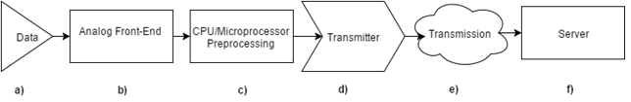

Figure 1. WNR System Breakdown

The involved components are discussed below:

## **Analog Front End**

The analog signal generated by the brain and picked up by the electrodes go through the process of amplification and then Analog-to-Digital-Conversion (ADC). These two processes combined are termed the analog-front-end (AFE).

The amplification is important because brain signals have amplitudes on the of 100 uVpp (micro volt peak-to-peak) to 1 mVpp (millivolt peak-to-peak). To minimize the ADC error, the analog signal is first passed through a good amplifier which has a very low cut-off frequency (~0.01Hz) before being converted to a digital signal.

The amplification and ADC processes are integrated and implemented by the RHD2000 series of Intan TechnologiesTM. Our current choice of AFE chip is RHD2132, which offers 32 analog input channels. Because the current status quo of number of contacts points of a single ECoG electrode is ~16, 32 will give us sufficient margin for future improvement.

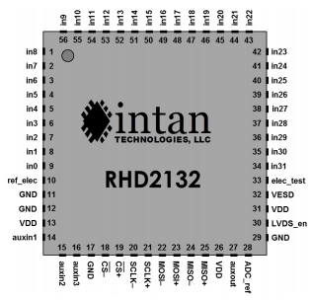

Figure 2. Intan Technologies RHD2132 Chip pinout

For development, Intan offers amplifier board which have RHD2132 chip soldered onto a custom PCB. This amplifier board, as mentioned, requires an additional LVDS component to communicate to. However, the LVDS converter will not be necessary in the final design as we will opt for a much less power-consuming standard CMOS signaling.

The RHD2132 communicates using standard Serial Peripheral Interface Bus (SPI) protocol. To program the chip, corresponding SPI pins on the RHD2132 chip are connected to the SPI pins on our microcontroller - nRF52. The RHD2132 chip is thus programmed through nRF52. Detail instructions of SPI commands built into RHD2132 can be found in its datasheet.

The functionality of the Intan RHD2132 has been verified as follow:

1. 6mVpp 10Hz Sine wave is generated by a function generator
2. The sine wave output is fed into RHD2132 analog input channel
3. The digital signal after amplification and ADC is transmitted to the computer over UART
4. The resulting signal is compared against the original signal

The spectrum of the digital data recorded by the Intan RHD2132 is plotted as follow:

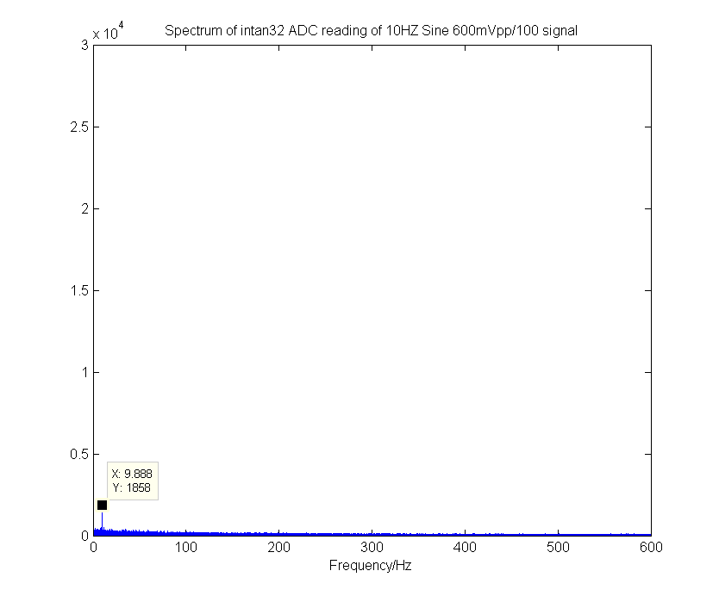

Figure 3. Spectrum of digital signal converted from 10Hz 6mVpp sine wave

From the spectrum we can clearly see a peak at 10Hz, corresponding to the frequency of the input sine wave. This verifies the functionality of the analog-front-end chip RHD2132.

## **Compression**

Data compression is important to the application because the Bluetooth Low Energy (BLE) protocol, although consumes very little power, has rather strict throughput restrictions. As such, it is difficult to transmit all the digital signals without performing some form of preprocessing (Compression).

The final design of WNR uses an ultra-lightweight compression algorithm called Heatshrink. This compression algorithm is developed based on a lossless compression algorithm called Lempel–Ziv–Storer–Szymanski (LZSS). This compression algorithm is particularly suitable for embedded purposes because of its small size.

To use this compression algorithm, we ported existing library files into the nRF52 chip. The compression algorithm is ran after a pre-initialized 8 kBytes data buffer is populated with 8-bit ADC data that is obtained from the AFE. The data after compression is passed to the wireless transmission module to be sent to the terminal.

The compression is implemented with the buffer manager. The buffer manager contains 16 buffers for corresponding channels. When the buffer manager is populated with converted digital data, it automatically compress the data and call the sending handler to send the data over bluetooth low energy communication protocol. If the buffer is full during compression, it will flush the existing data and take the compressed data from the breaking point.

The data compression rate has been tested on actual patient data, and the compression ratios are presented as follow:

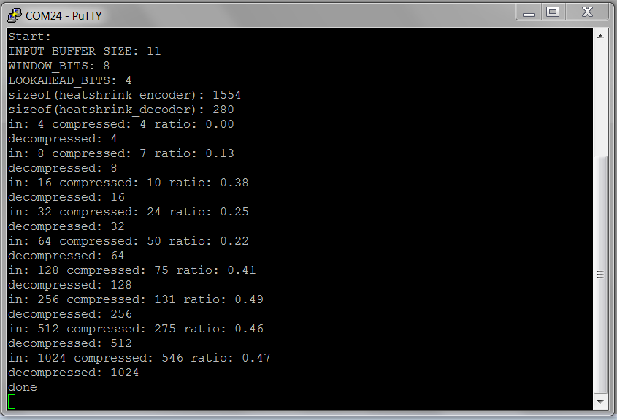

Figure 4. Compression ratio of Heatshrink on real patient data.

in - input data length in Bytes; compressed - compressed length in bytes; ratio - compression ratio

We found through empirical data that the optimized tradeoff point with efficiency and space is 8kB, where the compression ratio is 0.501. This is equivalent to the amount of data generated in 0.5 seconds on a single probe.

## **Bluetooth Low Energy(BLE) Wireless Transmission**

nRF52 has a BLE component on-chip. Thus, creating wireless transmission functionalities entails programing nRF52.

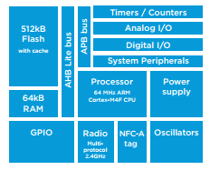

Figure 5. Integrated Systems on NRF52 SoC

For the purpose of this project, we need to establish a 1-to-many communication scheme with multiple peripheral chips (chips that collect brain signal) to a central chip (chip that interfaces with terminal where data from all peripheral chips can be accessed remotely).

To maximize throughput and minimize BLE overhead, a custom BLE service is created based on Nordic’s Nordic UART Service (NUS). Each peripheral chip is to be programmed to place data after compression into a data structure that uses this BLE service. The peripheral chips are programed advertise using NUS UUID. Once the peripheral is discovered by a central and connection established, the peripheral will begin sending compressed data to the central device.

The central place a key role in communicating with multiple peripherals. Because all the peripherals are sharing the same BLE service, the central simply needs to create an array of connection handles to keep track of the peripheral devices that are connected to it. The central will then switch between peripheral devices and request for compressed data to be sent to the central regularly from all devices.

To put things in perspective, the WNR system consists of a receiver or terminal, such as a computer or phone application, that will request connection with up to 16 independent electrodes. Each electrode will have the capability of sending the data it samples from the brain to the receiver application using its wireless BLE module. The receiver application will then be able to display the data received in real-time or manipulate the data for other applications. In BLE terminology, the receiver application will be the single central device in the system, and the electrodes will all be acting as peripheral devices. This conveniently forms a star topology, where connections are only between the central and one of the peripheral devices; peripheral devices do not communicate with each other. This topology is one of the simplest topologies to work with because data transfer is in one direction, from peripheral to central, and it maximizes throughput from central to peripheral devices without requiring any type of complicated communication protocol. The following figure shows an example of a network that operates in a star topology.

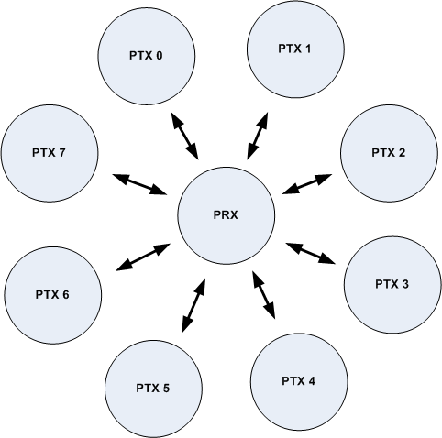

Figure 6. Example of a star topology; PRX is the central device and the PTX devices are peripherals

The received data is then decompressed by the central device and fed back to terminal (a PC) using [Universal asynchronous receiver/transmitter](https://en.wikipedia.org/wiki/Universal_asynchronous_receiver/transmitter) (UART) protocol over USB. The terminal application then has its own discretion as to what it does with the data. The terminal data could do, but is not limited to, the following: plot the data in real-time, transform the data (such as taking a fast Fourier transform) for other applications, and analysis.

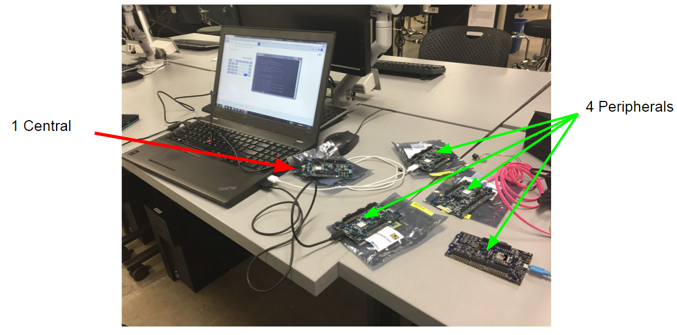

Figure 7. Setup of one-to-many(4 peripherals to 1 central) communication testing

## **Power Systems**

The power system of the WNR system is pretty straight forward. The device is only powered via non-rechargeable batteries. The batteries selected must fit within the size requirements of 8mm diameter and ideally 4mm in height to allow for the rest of the system components to fit within the ideal desired 10mm height.

Currently, the WNR system is using off-the-shelf hearing aid device batteries. The medical grade batteries are utilizing zinc-air technology which allows for compact, lightweight power transmission to the rest of the WNR system. Our choice of Zinc Air P13 batteries are able to provide 310mAh at 1.45 V in just a 7.9mm diameter by 5.4mm height, weighing just 0.83g. However, the 1.45V is not enough voltage to power all the components in our system as our chips work at an ideal voltage of 3V. We will be using 2 Zinc Air P13 batteries in series to provide 2.9V at 310mAh, which will be sufficient enough to power our system for at least 24 hours. The batteries therefore will be stacked on top of each other and placed onto the negative battery pad and secured by the positive battery screw cap.

We have measured and calculated the total power draw of the WNR system to be 169mAh for a 24 period operating period, which is well under the capacity of our P13 Zinc Air battery setup. The Intan A2D chip takes 22mAh to run for 24 hours, while the BLE transmission is the heaviest current consumer at 147mAh for 24 hours.

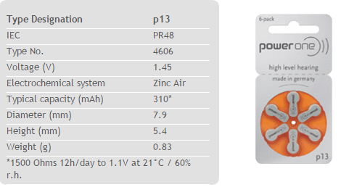

Figure 8. Zinc Air P13 Battery Specifications

Ideally, the battery technology will be updated before going into mass production with a custom higher density lithium ion battery providing more than 500mAh at 3V, which will provide us with battery life lasting about 3 days., which will help make the system more convenient such that the batteries do not need to be replaced everyday.

## **WNR System Housing**

The final design of the alpha version of WNR system will be enclosed in an 3D printed enclosure cap measuring 8.5mm in diameter by 12mm in height. Inside the cap will be the PCB containing all of the WNR system’s necessary components such as electrode inputs, A2D chip, Bluetooth Low Energy chip, and battery. The components will each exist on its own layer of PCB and manually connected via jumpers to each other layer. The electrode inputs will exist on the bottom layer of the PCB along with the A2D chip. The next layer will be the bluetooth chip layer. Finally the last layer will be the negative battery interface pad. These 3 PCB layers are to be printed and milled by a PCB machine and cut into a 8mm diameter circle. The 3 layers will be connected by jumpers and inserted into the 3D printer enclosure cap and topped off with positive battery connector screw cap. The bottom of the cap allows for the electrode needle probe pins to connect to the first layer of PCB with the electrode input holes.

For the mass production of the WNR system, the WNR system will be enclosed in an IP68 medical grade aluminum cap containing the PCBs with A2D and Bluetooth Low Energy chips. This will ensure the device is dust and waterproof for submersion in water past 1m. The PCBs will also be professionally printed on a multilayer PCB without the need for jumper connectors and will allow for a lower total stacked height. The layered PCB will be inserted into the milled aluminum cap and topped off with an aluminum battery connector screw cap.

## **LBM Cost Analysis**

The assembly of WNR product can be divided into sub-assembly of four subsystems. Due to the special nature of PCB boards assembly, the assembly phase should also be followed by a testing/debugging phase. The labor cost for two different phases are estimated separately. The assembly process, which is more repetitive and mechanical work, requires less labor cost than the technical work of testing/debugging. The on-board materials, such as capacitors and inductors, may require bulk purchase, and cost is not determined by the unit price. A simplified version of cost analysis is attached below:

|  |  |  |
| --- | --- | --- |
| Process Step | Material Cost | Labor Cost |
| Intan Assembly | $ 81.33 | $ 80.00 |
| Intan Testing/Debugging | / | $ 490.00 |
| Nordic Assembly | $ 402.35 | $ 40.00 |
| Nordic Testing/Debugging | / | $ 350.00 |
| Battery Board | $ 21.18 | $ 27.50 |
| Full Assembly | $ 33.00 | $ 120.00 |
| TOTAL | $ 537.86 | $ 1107.50 |

## **Standards and Regulations**

*Overview:*

The purpose of this section is to list out the protocol standards and government regulations that WNR must take into consideration during the project. The document first discusses the government regulations that pertain to the project, and then goes into details about the technical standards that may apply.

*Government Regulations:*

1. FDA - Food & Drug Administration[26]



FDA is a federal agency of the United States Department of Health and Human Services. It is responsible for protecting and promoting public health through multiple aspects of daily life, one of which is medical devices. The Center for Devices and Radiological Health (CDRH) branch of FDA is responsible for the premarket approval of all medical devices, as well as overseeing the manufacturing, performance, and safety of these devices.

There are two different types of requests submission for FDA regulation: “FDA-Cleared” and “FDA-Approved”. Since there are already existing similar products on the market, the WNR device falls in the category of “FDA-Cleared”, means it needs to be proved as “substantially equivalent” to the predicate devices already on the market. The electrode and microprocessor, especially the Intan chip front end are mature products from market, so proving this component will not be an issue. Another component of the system is the wireless transmission system installed on the device, which needs to demonstrate “safety and efficacy”. The Bluetooth Low Energy® protocol used on the transmission module fits IEEE-802.15.1 standard, which also has been proven to be harmless to people, given the vast number of products that exist on the consumer. Since the wireless neural recorder this project aims to create uses the functionality of two existing products on the market that has been FDA approved, it should not be difficult to secure approval for the entire system.

1. FCC - Federal Communications Commission[27]

 

The Federal Communications Commission is an agency that regulates interstate communications. One important related function is the control of radio frequency bandwidth. Since the WNR device involves wireless communication, it falls under FCC’s concern. The Bluetooth Low Energy protocol, IEEE-802.15.1, used in this process specifically needs a Bluetooth Compliance and Certification clearance from the FCC. The market release of this project’s wireless neural recorder product requires both qualification and certification from the FCC as well. The BLE module that will be used for wireless transmission is a component made from Texas Instruments. Very little deviation from the device will be necessary to create a communication network for wireless neural transmission, so seeking FCC qualification when incorporating an already qualified device from the market should be straightforward.

For the FCC certification, the team will directly apply to the FCC. The application process requires a preparation of materials: cover letter, test report from lab experiments, user's manual, schematics with parts list, block diagram, a photo of the test setup, internal/external photos, and the system’s operational description.

3. HIPAA - Health Insurance Portability and Accountability Act[28]



WNR device is mainly related with Title II of HIPAA (Administrative Simplification provisions), which standardizes electronic healthcare transactions. Because the WNR device does not involve medical information transaction, the main concern for the project is the Privacy Rule that regulates the use and disclosure of Protected Health Information held by health institutes or personnels. The information gathered from WNR device is considered private and should not be disclosed to third parties without permission. To address this concern, the wireless transmission channel should be encrypted and no data is stored in on-board memory. Since the product is still under development and testing, the encryption method will be discussed in detail after a more sophisticated prototype is produced.

***Engineering Standards and Protocols:***

1. I2C (Inter-Integrated Circuit)[29]



Invented by Philips Semiconductor (Now NXP Semiconductor), I2C bus protocol is a multi-master, multi-slave, single-ended serial computer bus that is widely used in microprocessor applications. It is still maintained by NXP Semiconductor and the most recent standard announced was on 4th, April 2014. The I2C protocol is written interchangeably as I2C or IIC. For a large array of sensors like accelerometer and temperature sensors that could be incorporated in WNR project, I2C bus is used as the means for communication. Although the protocol is still maintained by a company, I2C protocol is free since October 10, 2006. Fees are still required to obtain I2C slave addresses allocated by NXP although such cost will be contained in the price of the components that uses I2C. The main advantage of I2C is that it only requires 2 lines and they are bidirectional data lines. However I2C is more complex to set-up, but once stable it can be easily extended to additional applications as long as your bus wiring doesn't get too long or large.

1. SPI (Serial Peripheral Interface)[32]

SPI, invented by Motorola, is a single-master, multiple-slave, four-wire serial bus communication protocol that is widely used to communicate data between one master and multiple users. The protocol aims to provide data communication between devices, just like I2C. SPI is a synchronous serial transmission scheme that requires four wires to connect the master to each slave. One line is the clock line, which synchronizes the rate at which data is sent and received between the master and slave. There are two data lines connecting the slave and master; one line is used by the slave to transmit data to the master and the other line is used by the master to transmit data to the slave. The fourth line is the slave select line. The master uses this line to select which slave it will communicate with. SPI has no default standard. As such, there are many different variations of the protocol, as entities create their own versions. There are no fees associated with SPI. For this project, SPI is a probable and viable method, that is simpler to use that I2C, for transmitting data between different components of the overall system. We will be using SPI as it is faster and easier to set-up than I2C. With our A2D, microprocessor components, and wireless transmission components, SPI seems to be the fastest and easiest way to implement our system.

1. Transmission Control Protocol (TCP)

For introduced by Vint Cerf and Bob Kahn in an Institute of Electrical and Electronic Engineers (IEEE) paper[30], the Transmission Control Protocol (TCP) has become a core protocol of the internet protocol suite where it works in complement with the Internet Protocol (IP). Together, these two protocols form the foundations for the TCP/IP construct of current internet standards. TCP is a communication protocol with high reliability and error-checking capabilities - characteristics required for the wireless communication portion of the project. As such, TCP could potentially serve as a viable communication scheme used to encode electrode signals to be sent wirelessly.

1. TIA(Telecommunications Industry Association)/EIA RS-232

First developed in 1969 by Telecommunications Industry Association[31], the RS-232 is a protocol that is used for serial communication in devices such as modems. For microprocessor applications, RS-232 is largely used for UART communication through USB cables. This allows developers of microprocessor applications to send data through USB connection to a terminal, like a computer, and read the signal from terminal serial port. Such protocol and the aforementioned usage greatly aids debugging when dealing with data-intensive applications, such as the WNR project. Nevertheless, RS-232 is a wired connection protocol and will therefore only be used for debugging purposes for our project. Actual data transmission will still make use of wireless protocols like TCP.

1. Bluetooth v4.1 Low Energy(BLE)[33]

Developed by BlueTooth, Bluetooth Low Energy is a wireless communication standard that enables reliable, low energy, short distance wireless communication. BLE operates on the 2.4 GHz spectrum. It uses Gaussian Frequency Shift-keying (GFSK) modulation at 1Mb/s. BLE supports both broadcasting radio signal from a signal transmitter as well as one-to-one communication between a transmitter and a receiver. Since the WNR project focuses on incorporating wireless communication on small medical electrodes, BLE serves as an ideal protocol that provides wireless capabilities at a very low energy cost but it lacks the throughput necessary for our data transmission needs at this time. However it is the most low power and secure option that we hope to be able to use in the future.

6. Bluetooth Classic v2.1 Basic Rate / Enhanced Data Rate (BR/EDR)[34]

Bluetooth Core Specification Version 2.1, referred to as Basic Rate/Enhanced Data Rate (BR/EDR), made it easier for consumers to connect Bluetooth devices. The Bluetooth RF (physical layer) operates in the unlicensed ISM band at 2.4GHz. The system employs a frequency-hop transceiver to combat interference and fading, and provides many FHSS carriers. Basic Rate supports a bitrate of 1 Mbps while Enhanced Data Rate supports a gross air bit rate of 2Mb/s. While Bluetooth EDR supports our data transmission needs, it does use more power than Bluetooth Low Energy but that is a tradeoff we will have to deal with right now.

## **Conclusion**

The WNR system is comprised of the following subsystems shown in the figure 1. To recapitulate the system’s operation, the brain signal that is fed into the system undergoes the following processes:

1. Amplified and converted to digital data by Analog-Front-End component
2. Compressed by nRF52 chip which integrates transmitter and microprocessor
3. Transmitted wirelessly by nRF52 over Bluetooth Low Energy protocol
4. Received by a central nRF52 which is connected to a terminal
5. Decompressed on the terminal

# **Testing and Results**

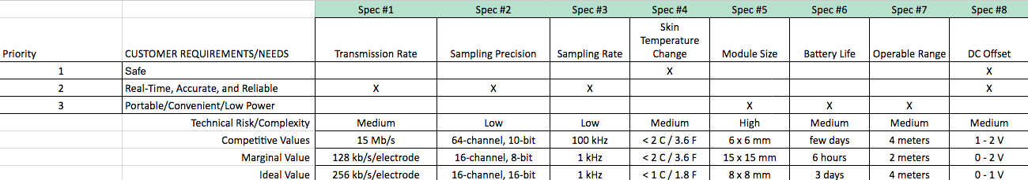

|  |  |  |  |  |  |  |
| --- | --- | --- | --- | --- | --- | --- |
| ***Spec Number*** | ***Test Method Description*** | | | | | |
| **1** | **While product is running, see if data is being sent in real time to the receiver; observe the number of bytes received by the receiver per unit of time. Calculate total data received over time of transmission** | | | | | |
| **2** | **Observe that the values being recorded from the electrode after transmission meets the minimum specifications by opening the data and calculating the bit precision** | | | | | |
| **3** | **Create a waveform from the data collected after transmission. Compare the waveform collected from the product to previous neural data waveforms and observe max and min sampling frequency** | | | | | |
| **4** | **Place WNR device so that it is in contact with the skin. Measure and record skin temperature before the device is running with infrared thermometer. Measure and record skin temperature after the device has been running after a while with infrared thermometer. Take the difference in temperatures to find the change in temperature.** | | | | | |
| **5** | **Measure dimensions of completed WNR cap device with calipers along 3 major axes.** | | | | | |
| **6** | **Observe current draw as the full device is running with digital multimeter. Additionally have battery percentage be recorded and transmitted over bluetooth in set intervals to log battery performance over time** | | | | | |
| **7** | **The device should be able to send valid data stream to server within range of 4 meters. Measure data packet loss as we physically move the transmission device further away from the receiver. Continue to measure transmission rate and or packet loss.** | | | | | |
| **8** | **When the device is operating, the feedback votage from the probe into the brain should not exceed 1V. Use oscilloscope to measure voltage change on probes to ensure proper operating range.** | | | | | |

We were able to test spec 1, 2, 3, and 7 at the same time as it was all related to wireless transmission of signals. We first sent sample ECoG data through the bluetooth low energy protocol and received it on our laptops. From there, we were able to calculate the total data rate received and noticed that it was only about 56kbps but we were in fact sending 1000 samples per second at 8 bits of data precision. We tested this while moving the transmitter and receiver at varying distances intervals from 0 to 4 meters away and received the same data results with us receiving 56kbps. Switching from ECoG data to an analog waveform generated by a function generator, we tested our transmission and received it again on our laptop and got the same waveform so we confirmed that we were able to effectively test and succeed at specs 1,2,3, and 7.

For spec 5, we created the PCBs to be 12mm by 14mm so we knew that it was going to be within the 15x15mm size. We measured it with the calipers again to make sure when we had the real PCBs on hand and confirmed that we did meet our design specification.

For spec 6, we tested calculated the voltage draw of a fresh battery with a multimeter and oscilloscope to know the starting voltage output and current draw. We checked again every hour for 6 hours to see that the device was still operating at 3V. We were able to meet the 6 hour minimum specification.

Unfortunately due to limitations, we cannot test specs 4 and 8 at this time as it requires some human testing and some testing that we are unable to complete with our current prototype and equipment on hand.

**Testing Spec 1: Transmission Rate of at least 128 kbps per WNR device**

The scope of this test is to ensure that the WNR devices are able to send neural data in real time with high enough throughput for our data requirement needs of 8 bit precision at 1KHz for 16 electrode contact points. This test will verify that the WNR system is working properly in real-time to gather all neural data from the electrodes and transmit data via Bluetooth Low Energy (BLE) to the central data recording device.

The equipment required for this test would be the:

* Completed WNR devices
* NRF52 development boards
* Computer

The final WNR devices would communicate to the computer connected with a central NRF52 development board.

In the prototyping stage, the peripheral NRF52 development boards will be communicating to a computer connected with a central NRF52 development board.

Steps:

1. Using the computer, load WNR devices / NRF52 peripheral boards and NRF52 central board with the Nordic SoftDevice BLE Drivers.
2. Compile and load the WNR devices / NRF52 peripheral boards with the BLE transmission code and sample neural signal data.
3. Compile and load the NRF52 central board with the data receiving and recording example.
4. Power on the WNR devices / NRF 52 peripheral boards such that they automatically advertise and connect to the NRF52 central board. Record transmission start time observed on laptop message.
5. Observe transmission data successfully being received on NRF52 central board connected to computer.
6. Stop transmission of data from WNR device/ NRF52 peripheral boards. Record transmission end time observed on laptop message.
7. Confirm continuous data rate of at least 128kbps from data transmitted over time by dividing total size of received data by difference in start and end transmission times.

The test will be confirmed to be successful if the WNR devices/ NRF52 peripheral boards were able to successfully connect and transmit data for at least 10 minutes at a constant calculated average throughput of at 128kbps. The test can be repeated for varying amounts of time from 1 minute to several hours to ensure consistent throughputs for varying amounts of time.

**Testing Spec 2: Sampling precision of at least 8 bits for 16 channels**

The scope of this test is to ensure that the WNR devices are able to sample analog data from the electrode’s 16 channels with at least 8 bit precision. This will ensure the data being transmitted and recorded will contain enough data resolution to be recompiled and displayed.

The equipment required for this test would be the:

* Completed WNR devices
* NRF52 development boards
* Intan RHD2132 A2D
* Function generator
* Computer

The final WNR devices would received analog data via the electrodes from the function generator and communicate the converted A2D data to the computer connected with a central NRF52 development board.

In the prototyping stage, the function generator will generate an analog signal for the intan chip to convert to a digital signal, which is then sent to the peripheral NRF52 development boards, which will be communicating to a computer connected with a central NRF52 development board.

Steps:

1. Turn on function generator to generate a triangular waveform of 1000 Hz or less
2. Connect function generator output to the WNR device electrode or directly to intan chip
3. Using the computer, load WNR devices / NRF52 peripheral boards and NRF52 central board with the Nordic SoftDevice BLE Drivers.
4. Compile and load the WNR devices / NRF52 peripheral boards with the A2D code & BLE transmission code.
5. Compile and load the NRF52 central board with the data receiving and recording example.
6. Power on the WNR devices / NRF 52 peripheral boards such that they automatically advertise and connect to the NRF52 central board.
7. Observe transmission data successfully being received on NRF52 central board connected to computer.
8. Stop transmission of data from WNR device/ NRF52 peripheral boards.
9. Confirm all received digital data contains at least 8 bits by opening data and checking if data type is uint8.
10. Reconstruct received data by plotting it and checking to see if waveform received is waveform generated by the function generator.

If the WNR devices/ NRF52 peripheral boards were able to successfully convert the analog data to digital and transmit that data, the test will be confirmed to be successful once the data received is checked to be of at least 8 bit precision by checking if the data type received is of uint8 and was reconstructed to be the signal generated by the function generator.

**Testing Spec 3: Sampling rate of at least 1 kHz**

The scope of this test is to ensure that the WNR devices are able to sample analog data from the electrode’s at a maximum of 1 kHz. This will ensure the data being transmitted and recorded will contain enough data to be recompiled and displayed.

The equipment required for this test would be the:

* Completed WNR devices
* NRF52 development boards
* Intan RHD2132 A2D
* Function generator
* Computer

The final WNR devices would received analog data via the electrodes from the function generator and communicate the converted A2D data to the computer connected with a central NRF52 development board.

In the prototyping stage, the function generator will generate an analog signal for the intan chip to convert to a digital signal, which is then sent to the peripheral NRF52 development boards, which will be communicating to a computer connected with a central NRF52 development board.

Steps:

1. Turn on function generator to generate a triangular waveform of 1000 Hz or less
2. Connect function generator output to the WNR device electrode or directly to intan chip
3. Using the computer, load WNR devices / NRF52 peripheral boards and NRF52 central board with the Nordic SoftDevice BLE Drivers.
4. Compile and load the WNR devices / NRF52 peripheral boards with the A2D code & BLE transmission code.
5. Compile and load the NRF52 central board with the data receiving and recording example.
6. Power on the WNR devices / NRF 52 peripheral boards such that they automatically advertise and connect to the NRF52 central board.
7. Observe transmission data successfully being received on NRF52 central board connected to computer.
8. Stop transmission of data from WNR device/ NRF52 peripheral boards.
9. Reconstruct received data by plotting it and checking to see if waveform received is waveform generated by the function generator and is of the operating frequency of up to 1000 Hz and is the same frequency that was generated by the function generator.

If the WNR devices/ NRF52 peripheral boards were able to successfully convert the analog data to digital and transmit that data, the test will be confirmed to be successful once the data received was reconstructed to be the same frequency signal generated by the function generator. The test will be repeated for signals from 0 Hz to 1000 Hz in 50 Hz steps to ensure that the entire frequency spectrum is able to be sampled and transmitted.

**Testing Spec 4: Skin temperature change of less than 2 degree C**

The scope of this test is to ensure that the WNR devices is safe for human use as a change of more than 2 degree C can cause discomfort and skin cells to start dying.

The equipment required for this test would be the:

* Completed WNR devices
* Infrared thermometer
* Piece of silicone rubber
* Computer

The room temperature of a piece of silicone rubber will be measured with the infrared thermometer. The WNR device will be running at full throughput when placed on the silicone rubber. The temperature of the rubber will be measured every 10-20 minutes.

Steps:

1. Take temperature of silicone rubber with infrared thermometer. Record baseline starting temperature
2. Run WNR device under full load with steps from Testing Spec 1.
3. Place WNR device on silicone rubber
4. Record temperature of silicone rubber every 10-20 minutes

The test will be conducted over the course of 3-4 hours with temperatures of the silicone rubber being taken at 10-20 minute intervals. If there was never a change of more than 2 degree celsius in the silicone rubber, the WNR test will pass this safety specification requirement.

However, this test depends on a few variables such as a airflow and room temperature. The test will have to be repeated in rooms of varying temperatures from 15.5 to 26.6 degrees Celsius. The ventilation of the room will also affect the airflow and cooling of the skin and device, so a well ventilated room and a not-so ventilated room will be used for testing. This will ensure the device operates in various standard environments and ensure it meets the specification requirements.

**Testing Spec 5: Module size of 10mm diameter**

The scope of this test is to ensure that the WNR devices is small enough to be placed on a patient’s head without interfering with other WNR devices. The form factor ensures that the WNR device is competitive in the market with its tiny form factor.

The equipment required for this test would be the:

* Completed WNR devices
* Calipers

Both the completed WNR PCBs that will be placed into the WNR device housing and the housing will be measured with calipers to ensure it meets the 10mm diameter requirement.

Steps:

1. Take PCB from WNR device
2. Measure PCB diameter with calipers along 3 major axes
3. Place PCB back into WNR device
4. Measure entire WNR device with calipers along 3 major axes

The test will be considered a success if the PCB diameter is no more than 10mm. We will have the diameter and height of both the PCB and completed WNR device for documentation purposes.

**Testing Spec 6: Battery life of at least 6 hours**

The scope of this test is to ensure that the WNR devices is able to be installed in a patient and send data for at least 6 hours.

The equipment required for this test would be the:

* Completed WNR devices
* NRF52 development boards
* Intan RHD2132 A2D
* Function generator
* Computer

The WNR devices will be transmitting at their full data rate while on battery power. When the device drains the battery completely., the signal to the NRF52 central device will be terminated and the timestamp of the connection lost will tell us how long the WNR devices have been running.

Steps:

1. Turn on function generator to generate a triangular waveform of 1000 Hz or less
2. Connect function generator output to the WNR device electrode or directly to intan chip
3. Using the computer, load WNR devices / NRF52 peripheral boards and NRF52 central board with the Nordic SoftDevice BLE Drivers.
4. Compile and load the WNR devices / NRF52 peripheral boards with the BLE transmission code and sample neural signal data.
5. Compile and load the NRF52 central board with the data receiving and recording example.
6. Power on the WNR devices / NRF 52 peripheral boards such that they automatically advertise and connect to the NRF52 central board. Record transmission start time observed on laptop message.
7. Observe transmission data successfully being received on NRF52 central board connected to computer.
8. Allow transmission of data from WNR device/ NRF52 peripheral boards until battery is drained. Record transmission end time observed on laptop message when battery is drained and disconnected from laptop.
9. Calculate operating time by taking difference of the start and end transmission times

This test will be considered a success if the WNR device is able to convert analog signals to digital signals and send it over BLE for an extended period of time lasting over 6 hours using batteries. For testing, we will have at least 4 WNR devices communicating at once to the computer, so we will have 4 data points to average and to see the minimum and maximum running times.

However due to the slight variance in capacity levels of batteries and the change in efficiency of energy transfer due to operating temperatures, we will need to repeat the test in rooms of varying temperatures from 15.5 to 26.6 degrees Celsius. This will allow us to understand the operating time of the WNR device is various standard environments and ensure it meets the specification requirements.

**Testing Spec 7: Operable range of at least 2 meters**

The scope of this test is to ensure that the WNR devices is able to transmit data wirelessly over a distance of at least 2 meters such that the patient is allowed to move about his or her room and ensure there is no loss in neural data transmission.

The equipment required for this test would be the:

* Completed WNR devices
* NRF52 development boards
* Intan RHD2132 A2D
* Function generator
* Computer

The WNR devices will be transmitting at their full data rate while the central device is moved to various locations around the room of varying distance.

Steps:

1. Measure out distance of 2m from placement of WNR device in all directions
2. Turn on function generator to generate a triangular waveform of 1000 Hz or less
3. Connect function generator output to the WNR device electrode or directly to intan chip
4. Using the computer, load WNR devices / NRF52 peripheral boards and NRF52 central board with the Nordic SoftDevice BLE Drivers.
5. Compile and load the WNR devices / NRF52 peripheral boards with the BLE transmission code and sample neural signal data.
6. Compile and load the NRF52 central board with the data receiving and recording example.
7. Power on the WNR devices / NRF 52 peripheral boards such that they automatically advertise and connect to the NRF52 central board. Record transmission start time observed on laptop message.
8. Observe transmission data successfully being received on NRF52 central board connected to computer.
9. Allow transmission of data from WNR device/ NRF52 peripheral boards until battery is drained. Record transmission end time observed on laptop message when battery is drained and disconnected from laptop.
10. Confirm continuous data rate of at least 128kbps from data transmitted over time by dividing total size of received data by difference in start and end transmission times.
11. Repeat step 6-9 for various distances up to 2 meters in various directions

This test will be considered a success if the WNR device is able to convert analog signals to digital signals and send it over BLE for a 10 minute period of time at its full data rate when the central laptop recording device is in various locations around the room. The laptop will be moved 2m in various spots from the transmitting peripherals and the data throughput test from specification 1 will be run to get the throughput. If the throughput received by the computer at 2m from the transmitting WNR device is sufficient, then we will be sure the WNR device is able to perform within the 2m requirements.

**Testing Spec 8: DC offset of RHD2132 < 2V**

The scope of this test is to ensure that the WNR devices is feeding less than 2 voltages back into the brain when it is recording brain signal. Otherwise this can cause problems with localizing which areas contributed to seizure voltage spikes. We are currently creating a wireless transmitter of neural signals and not yet implementing the feature of brain stimulation.

The equipment required for this test would be the:

* Completed WNR devices
* NRF52 development boards
* Intan RHD2132 A2D
* Function generator
* Computer

Steps:

1. Setup WNR system to be operating as normal without providing an input to the RHD2132 chip. Configure input pin 1 to RHD2132 to be converting (Note that this pin can be any of the 32 analog input pins).
2. Connect Pin1 of RHD2132 to an oscilloscope.
3. Read DC offset coming from the analog input pin. This is the current that will potentially be injected into patient’s brain.
4. Repeat step 1 to 3 for other analog input pins.

This test will be considered a success if the feedback voltage is less than 2 Volts.

# **Summary and Recommendations**

The development process is planned in the following phases:

1. Market research for chips need for the purpose
2. Initial prototyping using development kits of chips found in phase 1
3. Design and Fabricate custom PCBs which meets design requirements
4. Assemble chips with custom PCBs and perform various testings
5. Second Round of PCB design and testing
6. Securing approval for animal testing and begin animal testing
7. Secure FDA approval for clinical trials

Currently, Team WNR has completed the first 4 phases of the project and we are in the process of the second round of PCB designing and testing. We hope to finish phase 5 before the end of the semester year so future work can focus on animal testing and further improvement of the device.

Over the past 9 months, a list of key learning points were accumulated and presented as follow:

1. There exist many wireless protocols that are implemented on numerous well-developed chips. Each of these protocols have their respective pros/cons. For example:
   1. Wifi: highest throughput, high power consumption, larger form factor
   2. Bluetooth: good throughput, high power consumption, medium form factor
   3. BLE: lowest throughput, very low power consumption, smallest form factor.

To choose between these wireless protocols is to prioritize the relevant design specifications. Current team decided to choose BLE because of its low power consumption and small form factor, the throughput is low but satisfactory which is why we chose BLE. However, future effort may seek alternative wireless protocols or even create their own proprietary wireless protocols that are best suited for the application.

1. To create really small form factors, one need to minimize PCB sizes. The way we accomplished this was through stacking PCBs on top of each other to minimize the footprint of the complete module. However, we were still limited by the connectors between layers of PCBs. We used traditional small pitch jumper pins which are satisfactory but future effort could investigate into better possibilities like flexible PCB and more advanced connectors that allow for smaller form factor and, at the same time, better noise performance.
2. Power supply to the chip is currently done using off the shelf batteries. The challenge of power supply is that it needs to be small in size but large in mWh capacity. The best options we could find off the market was Zinc-Air P13 batteries that are widely use in hearing-aid applications. However, though these batteries sometimes provide good mWh capacity, they may not provide sufficient voltage which is necessary for proper functioning of specific chips. For example, the analog front-end chip (INTAN RHD2132) does not function properly with supply voltage under 2.9V. By putting two P13 batteries in series we can obtain a voltage of 3.0V. However, this voltage will change over time as the batteries get depleted which affects the functioning of the system. Therefore, future effort can look into ordering custom-made batteries that are better suited for the application - with larger supply voltage, comparable size and capacity.
3. To further shrink down the size of the device, future effort can also look into chip design. So far, the development has been centered around existing chips made by other companies. These chips are usually very powerful with lots of added features. However, one could further shrink down the size of the device by making custom chips that only contain features relevant to the task. This can also potentially cut down power consumption as fewer functionalities are used.
4. Animal testing and potential clinical trials are the most exciting part of the product design. Future effort will need to work closely with Dr. Nitin Tandon to secure opportunities for animal testing and potential clinical trials. As we have learnt over the past months, actual testings are the best places for improvements to be made.

The most important learning lesson is perhaps the need for thorough market research. Although it is unrealistic to research every single chip and wireless protocol available on the market with a short timeline, Team WNR did run into problems when previously undiscovered chips prove to be much better suited for the task than the ones the team decided to use. By doing more thorough market research, future teams can save themselves lots of time and effort by trying their best to stay on the right track.

# **Appendix A. Power Estimation for Intan RHD2000**

Total Power consumption of Intan RHD2000 is estimated for ECoG applications as per our project with the following specifications:

1. High cutoff frequency of 1kHz
2. Sample rate = 16 channels * 1 kS/s/channel = 16 kS/s
3. I/O, impedance measurement and temperature sensor turned off
4. Operating for 24 hours
5. Supply voltage of 3.3V

Power consumption for RHD2000 is listed as below:

1. Amplifier:
   1. Baseline = 200 uA
   2. Per kHz of upper cutoff frequency per ADC channel = 7.6 uA
2. ADC:
   1. Baseline = 510 uA
   2. Per kSamples per second per channel = 2.14uA
3. Supply Voltage, Auxiliary Inputs
   1. 40 uA

The total power consumption is then estimated as follows:

1. Amplifier current: 200 uA + 16*7.6uA/kHz*1 = 321.6 uA
2. ADC current: 510 uA + 2.14 uA/(kSample/s)*16 = 544.24 uA
3. Supply Voltage, Auxiliary Inputs: 4*10uA = 40 uA

Hence the total power consumption is 3.3V *(321.6+544.24+40)*(10^-6) = 2.99 mW. For continuous operation of 24 hours, it corresponds to 21.74 mAh.

# **Appendix B. Power Estimation for TI CC2650 and TI CC110L**

First, the power consumption derivations of the TI CC2650 are shown below[11].

1. Transmission at +0 dBm:
   1. Consumes 6.1 mA
   2. Power consumption with 3.3 V supply: 3.3 V * 6.1 mA = 20.13 mW
   3. To transmit continuously for 24 hours = 6.1 mA * 24 hours = 146.4 mAh
2. Transmission at +5 dBm:
   1. Consumes 9.1 mA
   2. Power consumption with 3.3V supply: 3.3 V * 9.1 mA = 30.03 mW
   3. To transmit continuously for 24 hours = 9.1 mA * 24 hours = 218.4 mAh

It is highly unlikely that a transmission power of greater than +0 dBm, so using an estimation of approximately 150 mAh (battery energy density required to transmit at +0 dBm for 24 hours) will suffice for analyzing the power feasibility of the system.

Next, the power consumption derivations of the TI CC110L are shown below[13].

1. Transmission at 315 MHz:
   1. Consumes 12.3 mA
   2. Power consumption with 3.3 V supply: 3.3 V * 12.3 mA = 40.59 mW
   3. To transmit continuously for 24 hours = 12.3 mA * 24 hours = 295.2 mAh

Transmission at 315 MHz consumes the least amount of power of all the transmission frequencies, and even then this transmission mode requires much more power than that of the CC2650. Additionally in order to use the C110L, the device must be connected to an external controller, like the TI MSP432. If the microcontroller is assumed to be in low-power mode for the entirety of the transmission period, then its effective current consumption is 0[12]. From the pure power consumption perspective, the CC2650 is the better choice for the project.

# **Appendix C. Power Estimation for TI CC2564 + TI MSP430F5438 System**

The derivations of the power consumption for the TI CC2564 are shown below[20].

1. Transmission at +4 dBm at 3.6 V
   1. Consumes 39.2 mA while transmitting at maximum data rate
   2. Power Consumption at 3.6 V: 3.6 V * 39.2 mA = 141.12 mW
   3. To transmit continuously for 24 hours = 39.2 mA * 24 hours = 940.8 mAh

This power estimation is higher than what is anticipated because the transmission rate may not have to be the maximum possible at all times. Additionally, the transmission power can probably be reduced to below + 0 dBm, which would reduce the power consumption.

The derivations for the power consumption for the TI MSP430F5438 are shown below[21].

1. Clock at 8 MHz in active mode at 3.0 V
   1. Consumes 230 μA/MHz
   2. Power Consumption at 3.0 V: 3.0 V * .230 mA / MHz * 8 MHz = 5.52 mW
   3. To run for 24 hours = .230 mA / MHz * 8 MHz * 24 hours = 44.16 mAh

If the two subsystems are combined, then the total power requirements are as follows.

1. TI CC2564 (Transmission at +4 dBm) + TI MSP430F5438 (Clock at 8 MHz active mode)
   1. Current density required for CC2564 = 940.8 mAh
   2. Current density required for MSP430F5438 = 44.16 mAh
   3. To run for 24 hours = 940.8 mAh + 44.16 mAh = 984.96 mAh

Of the four options for wireless transmission, this one consumes the most power by far.

# **Appendix D. Power Estimation for Nordic nRF52 Chip**

The derivations of the power consumption for the TI CC2564 are shown below[24].

1. Transmission at +0 dBm at 3.6 V
   1. Consumes 5.5 mA while transmitting at +0 dBm
   2. Power Consumption at 3.6 V: 3.6 V * 5.5 mA = 19.8 mW
   3. To transmit continuously for 24 hours = 5.5 mA * 24 hours = 132 mAh

Of the four options for wireless transmission available, this option consumes the least amount of power, so it would be the most optimal choice to choose to optimize for battery life.

**References**

[1] "Intan Technologies, LLC: Low-noise Amplifier Microchips for Electrophysiology, EKG, EMG, EEG, ECoG, and Neural Recording Headstages and Bio Instrumentation." *Pricing*. Web. 22 Oct. 2015.

[2] "Digital Electrophysiology Interface Chips." INTAN TECHNOLOGIES, LLC, 11 Dec. 2012. Web. 22 Oct. 2015.

[3] "Low-Noise, 8-Channel, 24-Bit Analog Front-End for Biopotential Measurements." Texas Instruments, 1 July 2012. Web. 22 Oct. 2015.

[4] Giuliano Antoniol and Paolo Tonella, “EEG Data Compression Techniques”, *IEEE TRANSACTIONS ON BIOMEDICAL ENGINEERING*, VOL.44, NO.2, Feb 1997.

[5] Tseng, R., B. Von Novak, S. Shevde, and K. A. Grajski. "Introduction to the Alliance for Wireless Power (A4WP) Loosely- Coupled WPT Specification 1.0." Introduction to the Alliance for Wireless Power (A4WP) Loosely- Coupled WPT Specification 1.0 (2013): n. pag. IEEE, 15 May 2013. Web. 21 Oct. 2015.

[6] "What's the Best Battery?" Advantages and Limitations of the Different Types of Batteries. Battery University, 01 Nov. 2010. Web. 21 Oct. 2015.

[7] "Battery Chemistry Comparison Chart." Battery Chemistry Comparison Chart. ICCNexergy, n.d. Web. 21 Oct. 2015.

[8] "Weird and Wonderful Batteries." Weird and Wonderful Batteries. Battery University, 17 Aug. 2011. Web. 21 Oct. 2015.

[9] Dondelinger, Robert M. "Batteries: From Alkaline to Zinc-Air." (2004): n. pag. FDA, Mar. 2004. Web. 21 Oct. 2015.

[10] "Battery Cell Types." Most Common Primary Battery Sizes Available. Epec, n.d. Web. 21 Oct. 2015.

[11] "CC2650 SimpleLink™ Multistandard Wireless MCU." Texas Instruments, 1 Feb. 2015. Web. 22 Oct. 2015.

[12] "MSP432P401x Mixed-Signal Microcontrollers." Texas Instruments, 1 Mar. 2015. Web. 22 Oct. 2015.

[13] "CC110L Value Line Transceiver." 1 May 2011. Web. 22 Oct. 2015.

[14] "Huffman Codes." *American Mathematical Society*. Web. 22 Oct. 2015.

[15] "Comparing Low-Power Wireless Technologies." *DigiKey Electronics*. DigiKey Electronics. Web. 23 Oct. 2015.

[16] "A Technology Comparison: Adopting Ultra-Wideband for Memsen’s File Sharing and Wireless Marketing Platform." Memsen Corporation. Web. 23 Oct. 2015.

[17] "A BLE Advertising Primer." *Argenox Technologies*. Web. 23 Oct. 2015.

[18] "New Aluminum Air Battery Could Blow past Lithium-ion, Runs on Water." *ExtremeTech*. ExtremeTech. Web. 14 Dec. 2015.

[19] "CC2640 BLE Throughput." *Texas Instruments Wiki*. Texas Instruments. Web. 14 Dec. 2015.

[20] "CC256x Bluetooth and Dual-Mode Controller (Rev. D)." Texas Instruments, 1 July 2012. Web. 13 Dec. 2015.

[21] "MSP430F543xA, MSP430F541xA Mixed-Signal Microcontrollers (Rev. E)." Texas Instruments, 2010. Web. 13 Dec. 2015.

[22] Horspool, R.n., and W.j. Windels. "An LZ Approach to ECG Compression."*Proceedings of IEEE Symposium on Computer-Based Medical Systems (CBMS)*. Print.

[23] Vokes, Scott. "Heatshrink Compression Library for Embedded Data." *Atomic Spin*. 2013. Web. 19 Apr. 2016.

[24] *NRF52832 Preview*. Trondhelm: Nordic Semiconductor, 2015. Print.

[25] "Wi-Fi HaLow." *Wi-Fi Alliance*. Web. 20 Apr. 2016.

[26] "Medical Devices." *U.S. Food and Drug Administration*. U.S. Food and Drug Administration. Web. 23 Oct. 2015.

[27] "FCC." *FCC*. Web. 23 Oct. 2015.

[28] "Health Information Privacy." *HHS*. Web. 23 Oct. 2015.

[29] "UM10204: I2C-bus Specification and User Manual." NXP Semiconductors, 4 Apr. 2014. Web. 23 Oct. 2015.

[30] Cerf, V., and R. Kahn. "A Protocol for Packet Network Intercommunication." *IEEE Transactions on Communications IEEE Trans. Commun.*: 637-48. Print.

[31] Mcghee, Joseph. "RS 232 and EIA/TIA 232 Serial Interface." *Handbook of Measuring System Design* (2005). Print.

[32] "SPI Implementation in IQRF for (DC)TR-7xD Technical Guide." IQRF. Web.

[33] "Bluetooth Smart (Low Energy) Technology." *Bluetooth Development Portal*. Bluetooth. Web. 23 Oct. 2015.

[34] “Basic Rate/Enhanced Data Rate (BR/EDR).” *Bluetooth Technology Basics.* Bluetooth.

Web. 13 Dec. 2015.